Goldfinch Termly Topic Tasks
Follow your interests and choose four topic task to complete over the term. You can complete them when it suits you best and bring them into school to share and celebrate with the class. How you present your projects is up to you, so be as creative as you can. For example, you could make models; draw and write creatively; use technology; bake and cook; carry out interviews; take photographs or go on trips and visits to places of interest. We look forward to seeing your completed projects.
Science  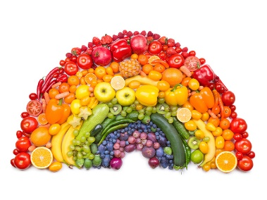  Create a food diary for a week. What changes could you make the following week to be healthier. | Physical health  Explore what a professional athlete’s week might look like. What might their diet and exercise regime look like?   | Titanic  Create a model of the Titanic.  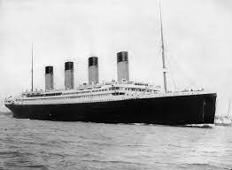 | Our World  Discover more about a different country in the World. Are there any famous landmarks there? How does it compare to England?  
Maths  Can you construct different 3D shapes out of different materials?  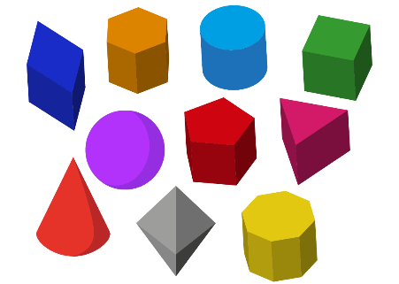 | Keeping safe on the roads  Go for a walk from your house and note down as many ‘road safety’ rules you have followed on your journey,   | Artist  Draw or paint your favourite animal in your own style.  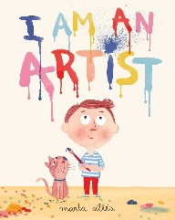 | Celebrations  Can you make some food that someone would eat as part of a celebration?  

