Goldfinch Termly Topic Tasks
Follow your interests and choose four topic task to complete over the term. You can complete them when it suits you best and bring them into school to share and celebrate with the class. How you present your projects is up to you, so be as creative as you can. For example, you could make models; draw and write creatively; use technology; bake and cook; carry out interviews; take photographs or go on trips and visits to places of interest. We look forward to seeing your completed projects.
Science  Can you create a habitat for an animal?  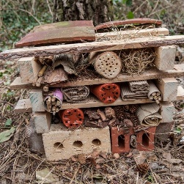 | Physical health  Can you create your own attack and defence game?  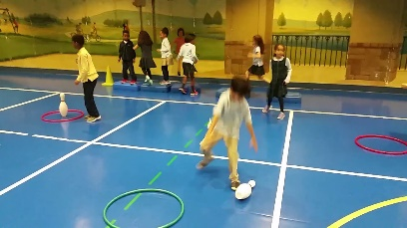 | Grace Darling  Create a poster about Grace Darling.  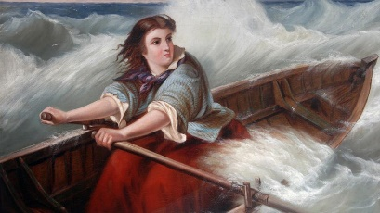 | Our World  Create your own ‘Little People Big Dreams’ book about a famous person from around the world.  
Maths  How many different ways can you represent 1/2, ¼, 1/3?  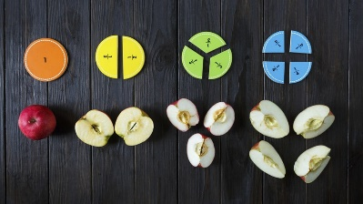 | Keeping safe  Create a poster about staying safe in the home.   | Artist  Create a self-portrait in your own style.  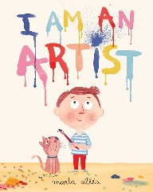 | Celebrations  Create a celebration card for someone who is celebrating a special occasion this term.  

