WEST END NEWS 19.09.25
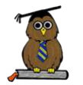
Excellence, Confidence, Compassion, Happiness
Personal Responsibility, Social Responsibility, Environmental Responsibility
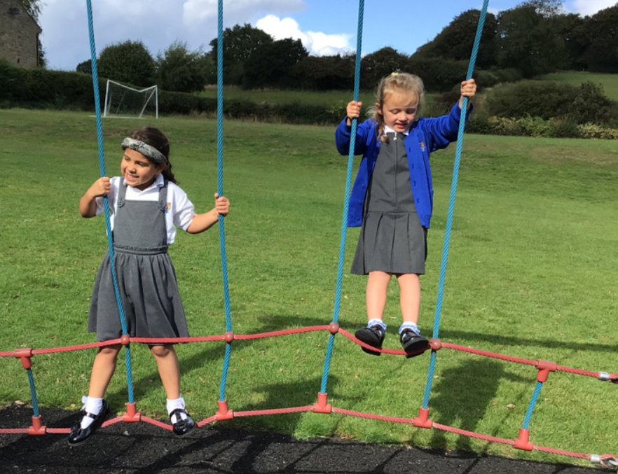
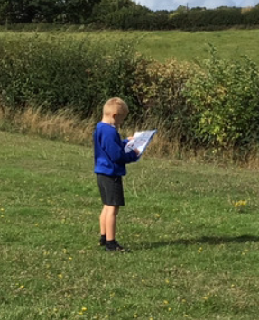
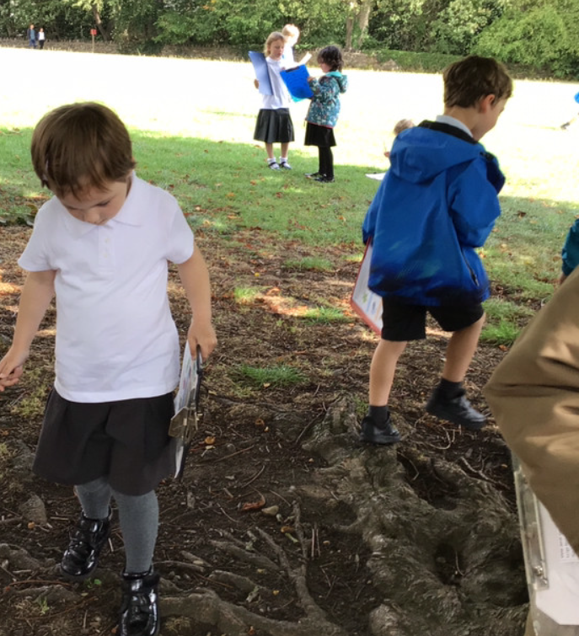
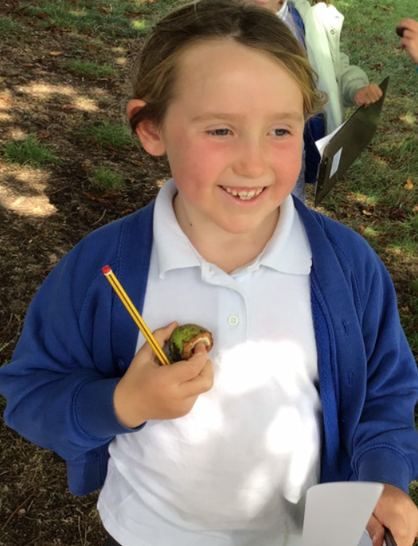
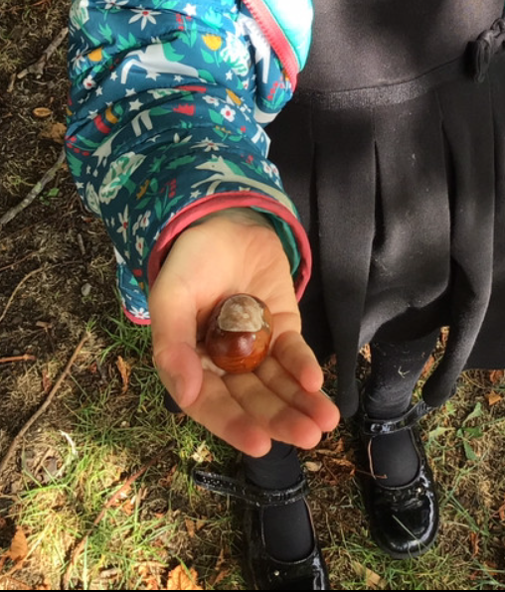
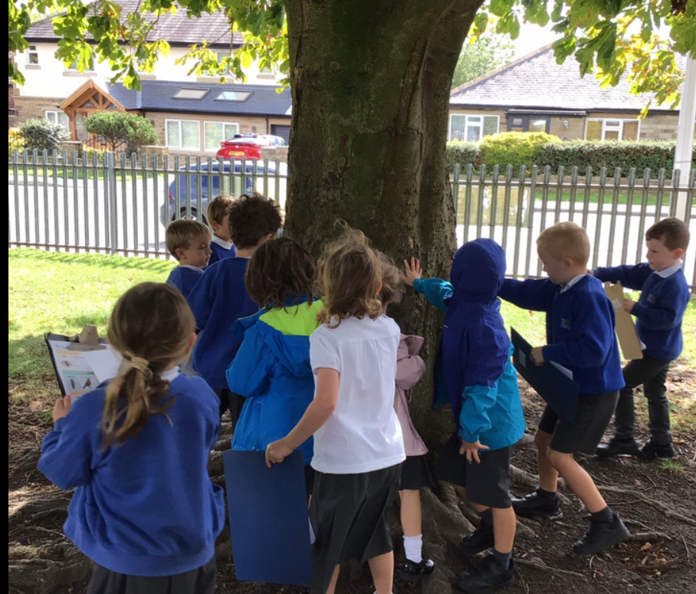
What’s been happening?
Making the most of the sunny weather.

We are very fortunate to have such a large outdoor space filled with excitement both natural and man-made. Over the past 3 weeks, we have been making the most of the space and the weather. Classes have been taking brain breaks by running their daily miles around our bottom playground and following our exercise route around the top playground. We have been using the fields and playground spaces for PE sessions and have been enjoying practicing skills for summer sports like tennis and cricket as well as enjoying time playing on the higher and lower-level trim trails.

We explore nature on our school site and in the local area to ignite a passion for caring for the environment. The children learn to appreciate the wonder of nature alongside development of their scientific investigative skills.

Children have also enjoyed picking fruit from our pear and apple trees and finding acorns and conkers (some of our parents have enjoyed this too!)

As the weather becomes wetter, please ensure your children have suitable coats so that we can continue to enjoy our outside spaces. We do like to get the children outside whatever the weather which does mean that we will be venturing out in the rain.

Assemblies:

We have a whole school assembly every day which children from Year 1- 6 attend. Each week we have a celebration assembly where we praise children for demonstrating our school values of personal, social and environmental responsibility.

Our assemblies for the rest of the week focus on developing our school values; learning about global and national events and themed days and religions events and celebrations across the main 5 world religions. These assemblies are delivered by our school staff through books, film clips, songs and group discussions. We also have assemblies delivered by visitors.

We had our first visit of the year from Duncan and his team from Horsforth Churches Together. They come to school termly to deliver their ‘Open the Book’ assemblies where they act out stories from the bible. This week, they had volunteer actors from Year 5 helping the story telling – they were superb!

