Goldfinch Termly Topic Tasks
Follow your interests and choose four topic tasks to complete over the term. You can complete them when it suits you best and bring them into school to share and celebrate with the class. How you present your projects is up to you, so be as creative as you can. For example, you could make models; draw and write creatively; use technology; bake and cook; carry out interviews; take photographs or go on trips and visits to places of interest. We look forward to seeing your completed projects.
Science  Investigate different objects and the materials used to create these. Why was the material chosen? How is it suitable?   | Physical health  Explore what a professional athlete’s week might look like. What might their diet and exercise regime look like?   | Magical mappers  Take a walk and notice the different twists and turns you take. What are your surroundings like? Draw a map to show your route so that someone else would be able to enjoy your journey.  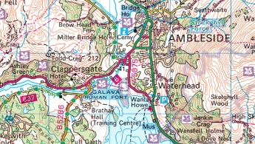 | Our United Kingdom  Discover more about a different place in the United Kingdom. Are there any famous landmarks there? How does it compare to where you live?  
Maths  Design a game to practise counting in 2s.  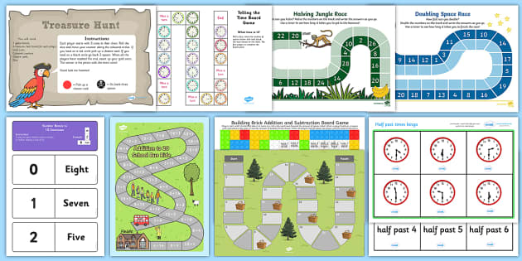 | Keeping safe online  Think about how to stay safe when working and playing games online.  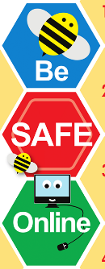 | Artist  Research about a famous artist. What sort of art do they create? What media do they use? Can you create a piece of artwork in the style of this artist?   | Celebrations  Does everyone celebrate Christmas? Are there any other religious celebrations that take place at this time of year?  

