FRENCH PROJECT AND ACTIVITIES : YEAR 4
Year 4 | Subject | Task | Resources
Week 1 | Maths | - Practice counting to 1 - 31  - Make number cards to play game | 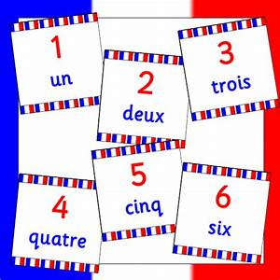
Week 2/3 | Design Technology  Art | - Use plastic straws to create a model of the Eiffel Tower.  - Can you create a model of another famous French landmark?  - Create a shield, logo or poster that displays the French motto ‘Liberte, Egalite, Fraternite' (Liberty, Equality, Fraternity). | 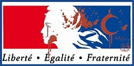  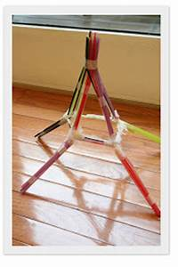
Week 4 | Art | - Make a poster that shows the names of different family members in French ( Y4) | 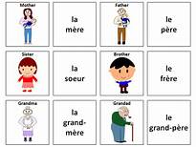  French Family
Week 5 | Music | - Can you learn the lyrics to a French song? | French Songs
Week 6/7 | History | - Can you find out about Bastille Day?  - (Use Euroclubschools website )  - Le 14 Juillet  - Can you make the dessert in the pictures? | 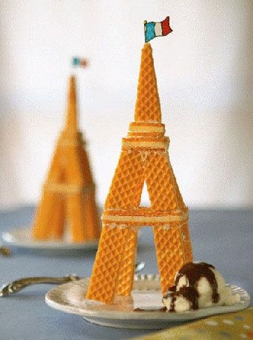  Euroclub Website

