Kestrel Topic Homework Summer 2024
This term we are learning about lots of different things in our exciting curriculum. This homework will let you investigate further something you are exploring in school. Please choose one of the suggestions below. How you present your work is entirely up to you. My ideas are just suggestions.
- We are studying Judaism. Create a drawing that shows what would be on the table for Shabbatt.  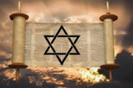 | - Create a poster for your buddies to ahow them how they can make sure that they stay healthy.   | - Create a poster celebrating who you are. There are lots of fantastic websites online to help you with this.  
- Find the most efficient way to measure the perimeter of your garden without taking a ruler or tape measure with you.  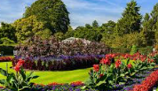 | - Create a leaflet advertising a Fairtrade product. Use the internet to add detail to your poster   | - Create a menu for Dracula’s castle. Use alliteration and description to link it to Dracula. e.g. Sunset steak, blood orange juice.  

