
West End Primary School
Uniform Policy
July 2023
Next review July 2026
In line with the DFE non statutory guidance on school uniforms the governing body of West End agree the following principals of the school uniform policy.
West End’s school uniform:
- promotes the ethos of a school
- provides a sense of belonging and identity
- sets an appropriate tone for education

The governing body believes that a school uniform is an important part of building a pupil’s sense of identity and belonging to the community of the school. It instils a sense of pride in the school and supports positive behaviour. Our policy has been written in accordance with the Equalities Act 2010 and the Human Rights Act 1998. We have considered pupils who share the relevant protected characteristics as identified in these acts.
We have also taken measures to ensure it is safe, practical, comfortable, and affordable. We will review and reflect on our policy and inform parents and carers of and sensible adaptations or exceptions to it in the event of circumstances such as extreme weather, school visits or special occasions.
Our uniform policy is for the children in main school Reception to Year 6, not our nursery children. We ask that Nursery children wear practical, comfortable and easy to manage clothing.

Our uniform consists of:
- royal blue sweatshirt /cardigan
- white polo shirt
- Grey or black school trousers (not joggers) / skirt / pinafore.
In the summer – grey or black school shorts or a blue gingham dress. Shorts should not be Lycra and should be mid-thigh length or longer.
- blue gingham dresses
- smart sensible black or navy shoes or boots (not trainers)

Children come to school from Year 1 up wearing their PE kit on their PE days. PE days will be communicated to parents/carers each half term. In EYFS the children change into their PE uniform as part of their physical development curriculum.

Our PE uniform consists of:
- Plain black shorts / skorts / tracksuit bottoms / sports leggings (suitable for school). Shorts or skorts must be mid-thigh length or longer.
- Trainers suitable for outdoor PE (not astroturf or football boots unless specifically requested)
- A house-coloured T shirt (red, yellow, green, blue or purple)
- A house-coloured Hoodie/sweatshirt (red, yellow, green, blue or purple)

It will be assumed that children in different coloured tops have brought them to keep warm under coats for outdoor play and they will be asked to remove them and hang them in the cloakrooms after playtime
Jewellery and hairbands:
We ask that children do not wear jewellery for school as, when playing, it can be unsafe to wear. If a child has their ears pierced we ask for studs only please. If these cannot be removed for PE, they will be covered with tape.
We recommend that children with long hair tie this up with small bands or clips. Hair accessories - We ask that headbands / hair clips are plain and discreet and do not have distracting features on them such as ears or attachments on springs.

Purchasing uniform :

Sweatshirts/cardigan, polo shirts, PE T shirts and hoodies in house colours embroidered with the school name and logo can be bought throughout the year direct from school.
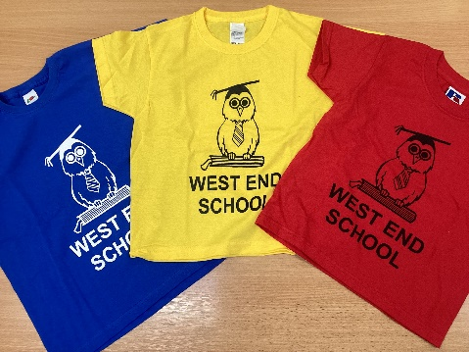
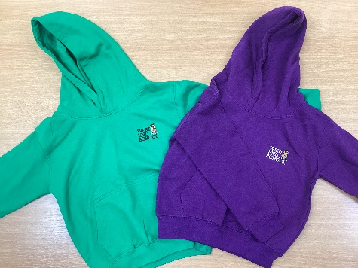
These items can be ordered and paid for through the shop in Parentmail accounts.
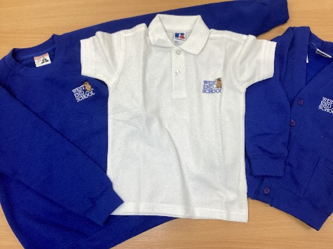
We ask that children in Early Years and Key Stage 1 bring their belongings in a schoolbook bag in order to save space in classrooms; these come in a variety of colours to choose from.

Accessibility and Sustainability :
All of our uniform items (without logo) are available at good prices from a wide range of shops and supermarkets.

We have a large range of preloved uniform of all sizes available which has been washed and is ready to wear available from our Friends of West End. This is available at no cost and can be collected from the school reception area.

School is provided with additional funding from the government to provide support for pupils from lower income families to ensure that they benefit from the same opportunities as all other children. This funding is called ‘Pupil Premium’. We pledge to use some of the Pupil Premium funding to provide uniform for those children who are entitled to it. Refer to the information on our website on Pupil Premium for eligibility and uniform provision.

PLEASE NAME ALL CLOTHING INCLUDING SHOES! This enables lost property to be returned to its owner with ease and reduces the need to replace items.
Lost property is held centrally in the school office for children, parents and carers to try to reclaim.

The governing body recognises its obligations to accommodate reasonable adjustments to the school uniform on the grounds of medical needs and will ensure the uniform is not discriminatory on the grounds of race, religion gender or belief.

Non-adherence:
The governing body will monitor that the school is considerate and discreet when trying to establish reasons for why a pupil is not adhering to the school uniform policy.

For government guidance on school uniform see:
https://www.gov.uk/government/publications/school-uniform
https://www.gov.uk/government/publications/cost-of-school-uniforms/cost-of-school-uniforms

