WEST END NEWS 17.10.25

Excellence, Confidence, Compassion, Happiness
Personal Responsibility, Social Responsibility, Environmental Responsibility
What’s been happening?
Year 3 – Cheer Dance
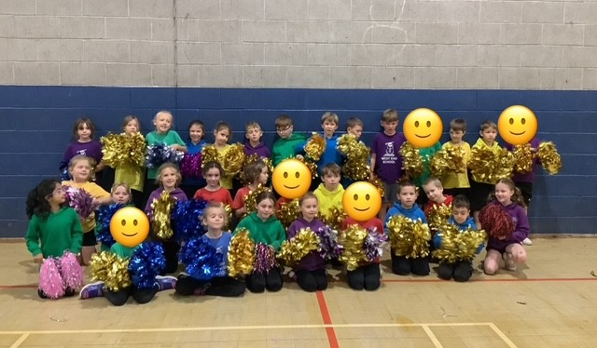
Year 3 had an amazing time at the cheer event on Monday! The children were full of energy and enthusiasm as they joined in with fun routines, learned new cheer moves and worked together as a team. Everyone loved the upbeat music and the chance to show off their spirit and coordination. It was a day full of smiles, laughter and school pride. ‘I thought the day was really good and fun’ -Maddie ‘I had the best time and enjoyed doing the jumps the most’ -Eva
Year 3 – Stone Age Workshop
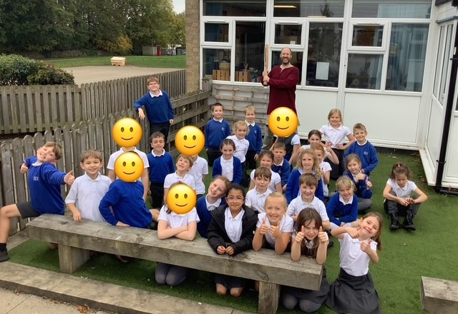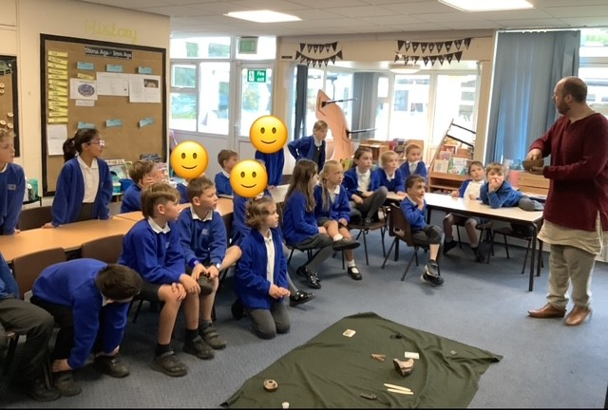
Year 3 also had a fantastic time on Wednesday when the History Squad visited for an exciting Stone Age workshop! The children were fascinated by the amazing artefacts, especially the real mammoth’s tooth and loved discovering what life was like thousands of years ago. They also had great fun playing a Bronze Age version of noughts and crosses and creating their very own Stone Age paintings. It was a brilliant hands-on day that really brought history to life and a wonderful experience that year 3 will remember for a long time! ‘We got to hold things that were thousands of years old!’ – Rosie ‘I loved the day because we played lots of old Stone Aged games’ – Ava B
Harvest collection
School council are asking families to support our local community foodbank for our harvest project. Thank you to all the families who have sent in donations already. We will continue to collect next week.
Admissions Consultation
Leeds City Council is running a public consultation on the 2027/28 admission policy for Leeds community and voluntary controlled schools. You can share your views until 1 December. Find out more at www.leeds.gov.uk/SchoolAdmissionsConsultations

