WEST END NEWS 10.10.25

Excellence, Confidence, Compassion, Happiness
Personal Responsibility, Social Responsibility, Environmental Responsibility

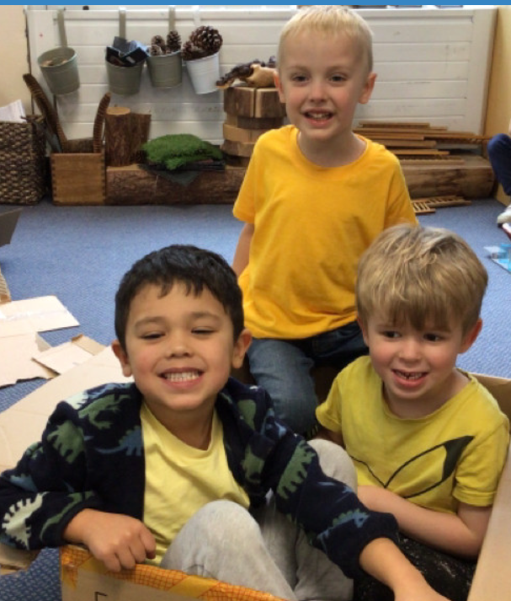

What’s been happening?
Wear Yellow for Mental Health Day
Every year World Mental Health Day is celebrated on 10 October. World Mental Health Day is about raising awareness of mental health and driving positive change for everyone’s mental health. We recognise how important it is to discuss mental health. We need to make sure our children know that talking about worries is a good way to improve mental health and that they can talk to any member of staff in school as well as adults at home.
We encourage anyone who is struggling with their mental health to reach out.

Smartphone Free Childhood
'Smartphone Free Childhood' is a parent-led grassroots movement with the aim of providing solidarity, support and solutions to parents struggling with what's become one of the defining parenting challenges of our time.
We will be hosting a parent-to-parent meeting 6-7pm on Thursday 16 October 2025 in the school hall to introduce the ideas behind a 'Smartphone Free Childhood' followed by an open discussion to better understand parent concerns and how we can help each other locally.
We'd love to see you there!
In the meantime, please email SmartphoneFreeChildhoodWestEnd@gmail.com. if you want to be added to the local WhatsApp group or have any general queries.
Lost Property:
We have increasing amounts of unnamed uniform and coats in our lost property. Please can you make sure that all items are named. Each half term, unnamed items are taken to the charity shop or washed and added to our preloved uniform.
Lost property is stored in the main school office. Parents are welcome to pop in to try and identify any missing items.

