WEST END NEWS 23.10.25
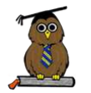
Excellence, Confidence, Compassion, Happiness
Personal Responsibility, Social Responsibility, Environmental Responsibility
What’s been happening?
Year 6 – Class Assembly and Residential!
Thank you to Year 6 for treating us all to an action-packed assembly where you recreated activities from your residential visit to Robin Wood.

Family Bedtime Story Evening
It was lovely to welcome so many people into school on Wednesday evening to take part in our bedtime story event. It was wonderful to have so many families sharing the evening with us. Making time to be together and to listen together to share the enjoyment of stories, poems in books. The children love hearing different stories read by themselves, friends, adults in school and adults at home. The benefits of sharing books with your children are enormous, for children of all ages.
Please find attached to this email some information from Mrs Broadbent around reading to and reading with your children at home.
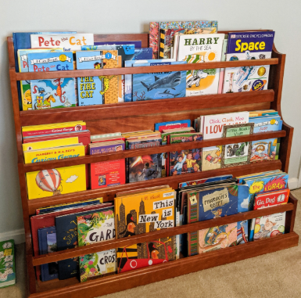
Additional Christmas performance
Due to the size of the cohort, a second opportunity to watch the Year 4 Christmas performance has been added to the diary.

"It was really fun doing the giant swing and raft building"

"It was an unforgettable experience" "All the activities were amazing"


