WEST END NEWS 03.10.25
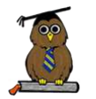
Excellence, Confidence, Compassion, Happiness
Personal Responsibility, Social Responsibility, Environmental Responsibility
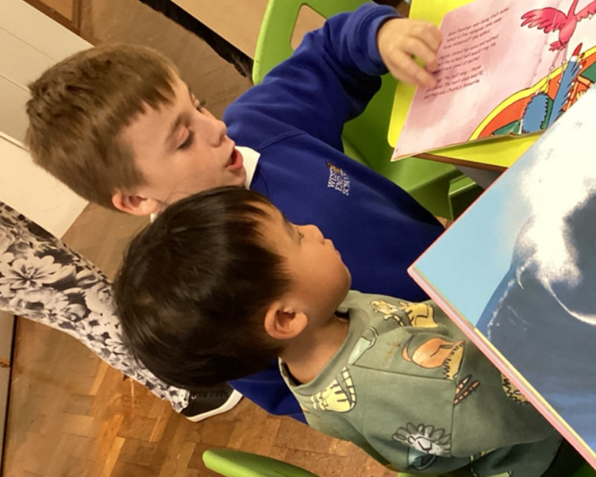
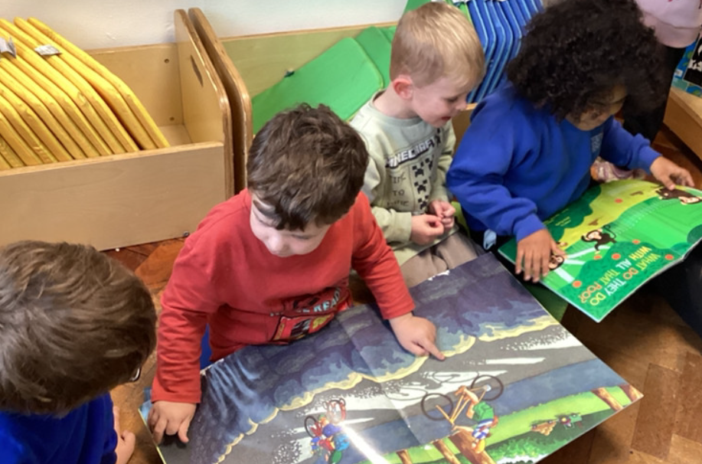
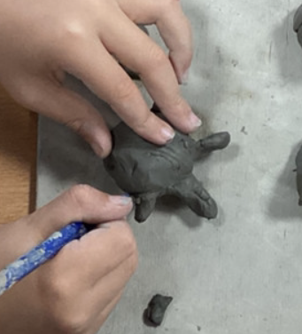
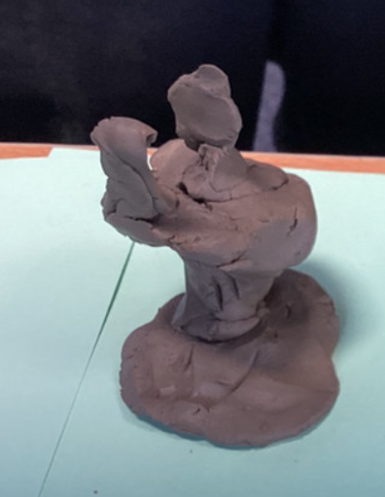
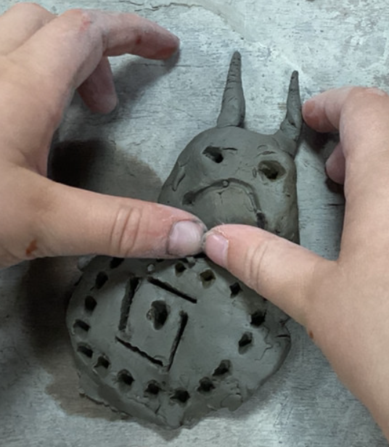
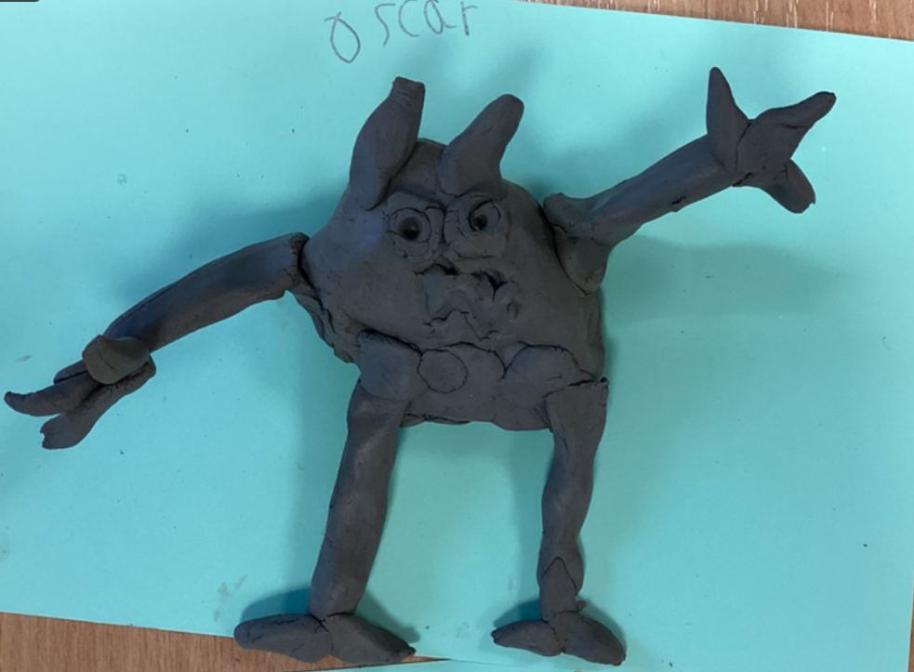
What’s been happening?
Making Monsters
Kingfisher Class have been inspired by the story We’re Going to Find a Monster. The children have designed and created their very own imaginative monsters, each one unique and full of character. They loved the process of bringing their ideas to life and had so much fun making their monsters!

Shared reading
Our Year 5 children enjoyed sharing their love of reading with our Nursery children today. Together they shared stories, talked about pictures and enjoyed exploring the wide variety of books available in our school library.

Coats:
As the weather becomes wetter, please ensure your children have suitable coats so that we can continue to enjoy our outside spaces. We do like to get the children outside whatever the weather which does mean that we will be venturing out in the rain.

