WEST END NEWS 26.09.25
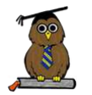
Excellence, Confidence, Compassion, Happiness
Personal Responsibility, Social Responsibility, Environmental Responsibility
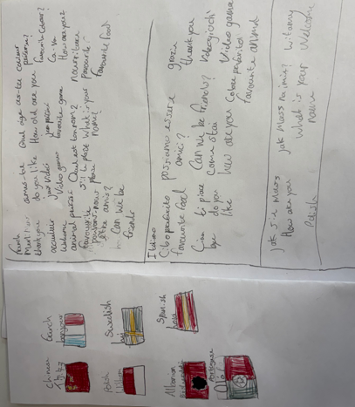
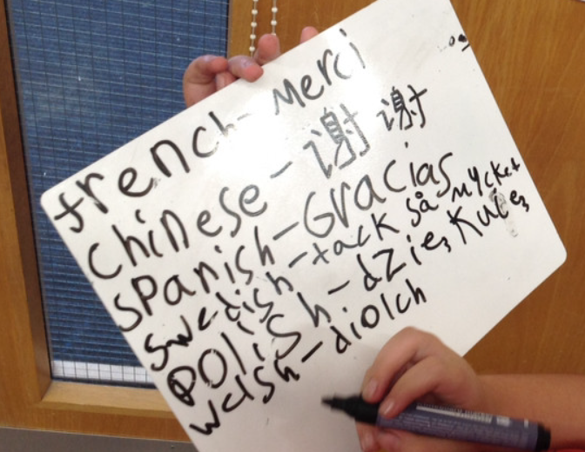
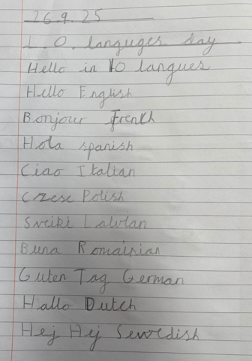
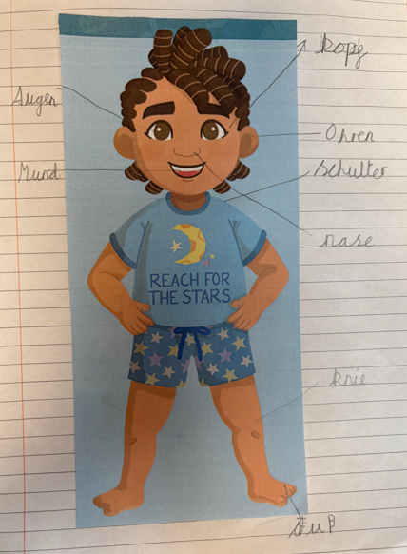
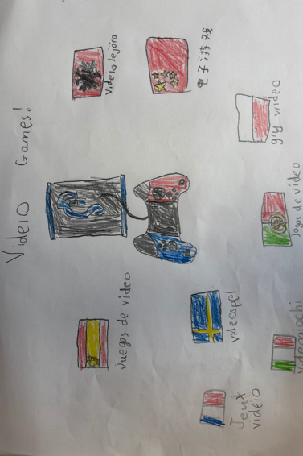
What’s been happening?
Assemblies:
Our daily assemblies throughout the week focus on celebrating and developing our school values, learning about global and national events and themed days, religions events and celebrations across the main 5 world religions. These assemblies are delivered by our school staff and visitors through books, film clips, songs and group discussions.

Last week, we had our first visit of the year from Duncan and his team from Horsforth Churches Together. They come to school termly to deliver their ‘Open the Book’ assemblies where they act out stories from the bible. A group of Year 5 children helped to tell the story – they were superb!

In assembly today, we looked at languages from around the world as part of European Day of Languages. In classes children continued to learn about the importance of language and communication. They shared and celebrated the languages spoken in our school and community and researched languages from around the world.

