WEST END NEWS 5.9.25

Excellence, Confidence, Compassion, Happiness
Personal Responsibility, Social Responsibility, Environmental Responsibility
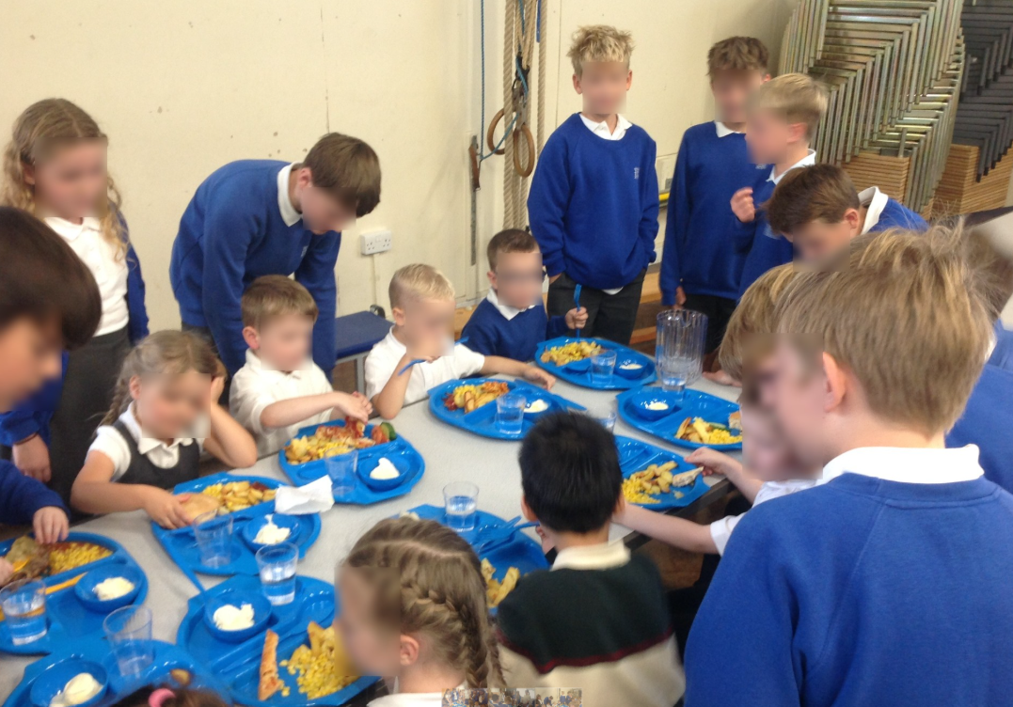
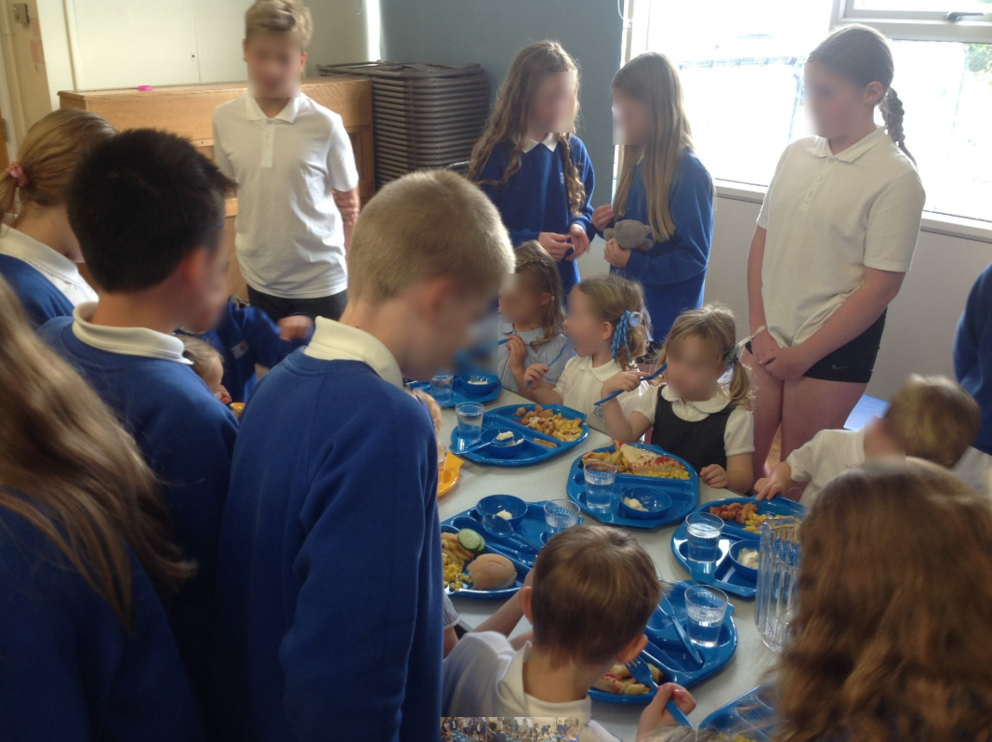
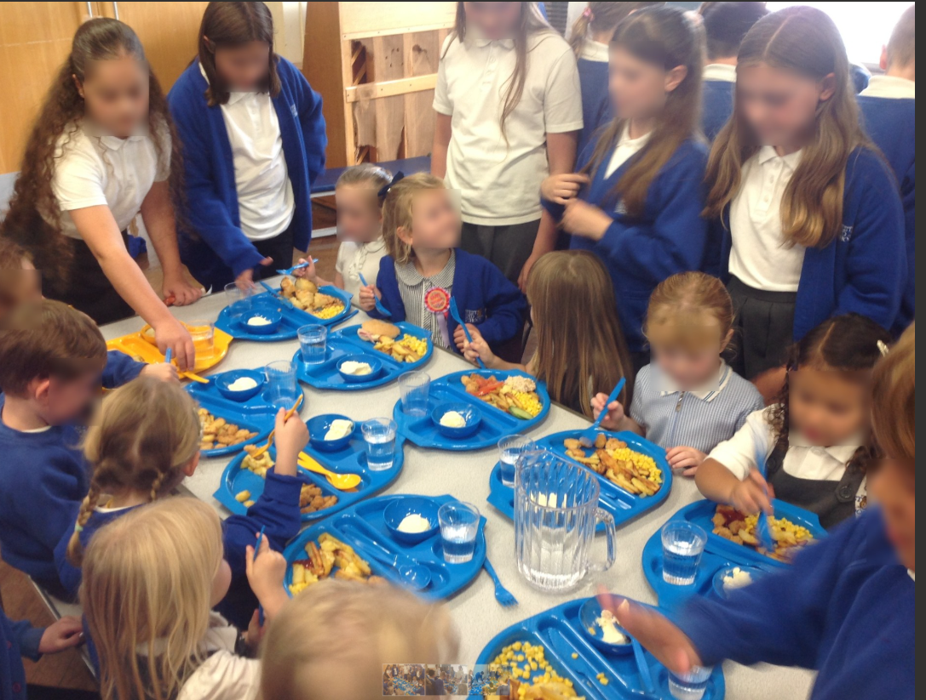
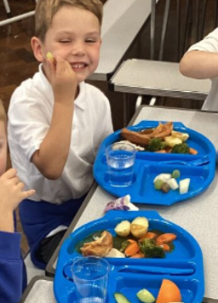
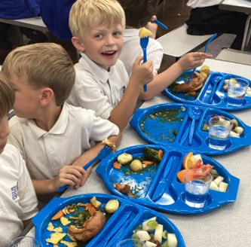
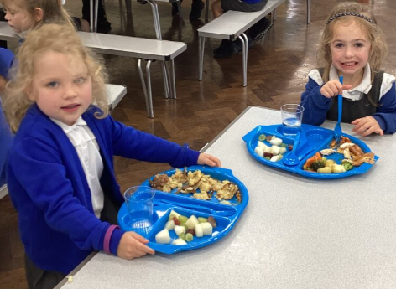
What’s been happening?
Welcome back! It has been wonderful welcoming children back into school and hearing all about their summer adventures.
Everyone has returned with enthusiasm and settled into new routines in their new classes. Our Reception children completed their first full day of school today! Our youngest children have been phasing into school this week and have settled brilliantly. Thank you to our Year 6 buddies for welcoming our Reception children. Your care and support are building a special friendship which will grow over the year.

School Meals
The new school meals have been extremely popular with the children. This week they have enjoyed a range of meals including homemade fish fingers and lasagne as well as roast dinners and popcorn chicken! Thank you for your patience with the changes to the ordering process. Laura has been working hard ironing out teething issues to make this a smooth as possible for parents.

Parent Carer Survey
This survey from Leeds City Council aims to gather feedback from parent carers about their experiences with the support provided to children and young people with Special Educational Needs and Disabilities (SEND) Click the link for further details.
https://www.leedsforlearning.co.uk/Article/176751?source=Roundup&guid=c9152ea6-7014-435e-96ef-2fa1041f150a
What’s happening next?
A list of key dates for the year will be sent to parents on Monday and will be posted on the school website: www.westendprimaryschool.org.uk Alterations may be made throughout the year. We will communicate these with you as soon as possible via our newsletter or parent mail messages.
Sporting events for school have not all been finalised. These events are dependent on availability from coaches as well as other schools. Dates for sporting events will be shared with as much notice as possible.
We are looking forward to another busy year!

