WEST END NEWS 07.11.25
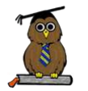
Excellence, Confidence, Compassion, Happiness
Personal Responsibility, Social Responsibility, Environmental Responsibility
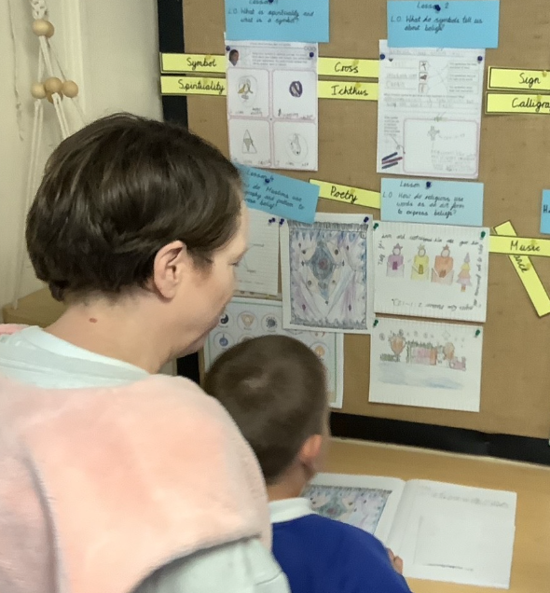
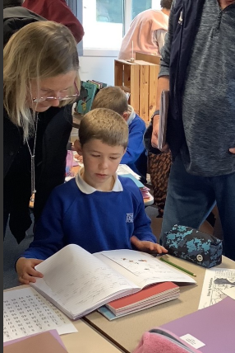
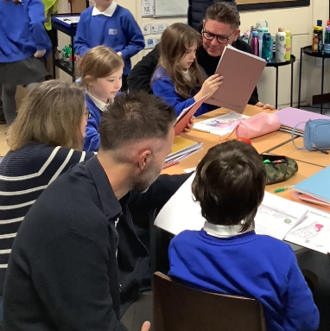
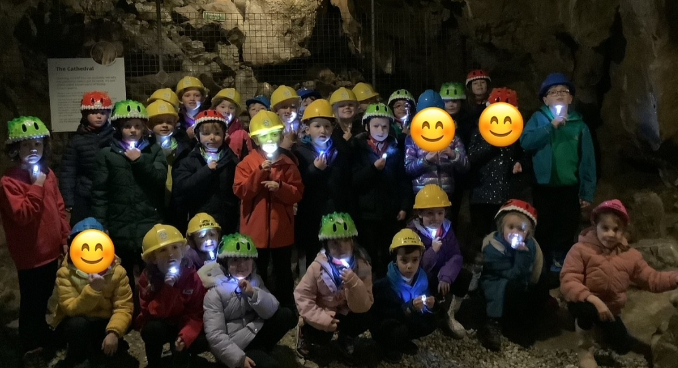
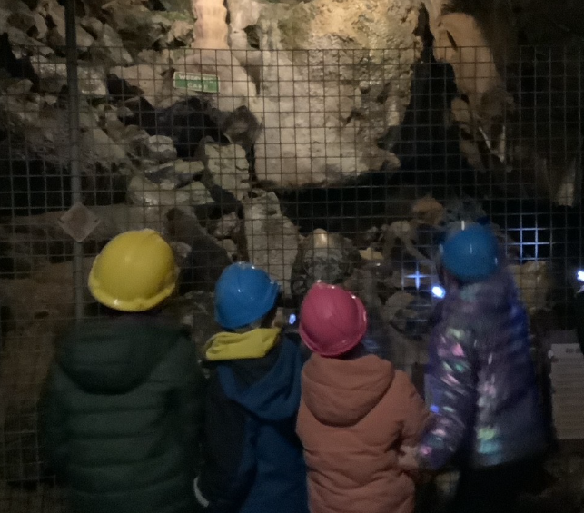
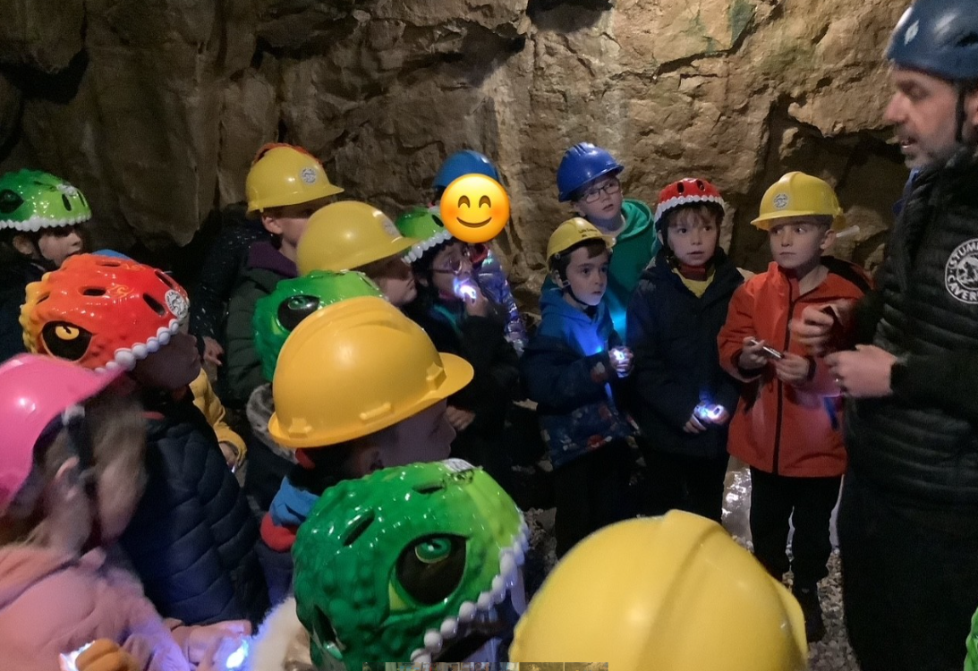
What’s been happening?
Year 3 visit to Stump Cross Caverns
Year 3 children visited Stump Cross Caverns this week to look at different layers of rock (linking to their learning in science) and to learn more about the Stone Age (linking with their learning in history). Everyone thoroughly enjoyed the trip!

PTA lottery
The PTA lottery closes this weekend. Don’t miss out! Tickets are only £30 and there are lots of prizes to be won across the year.
Open Classrooms
It was wonderful to welcome so many parents, carers, grandparents and siblings into school this morning. The children were thrilled to share their learning with you.

