WEST END NEWS 14.11.25

Excellence, Confidence, Compassion, Happiness
Personal Responsibility, Social Responsibility, Environmental Responsibility
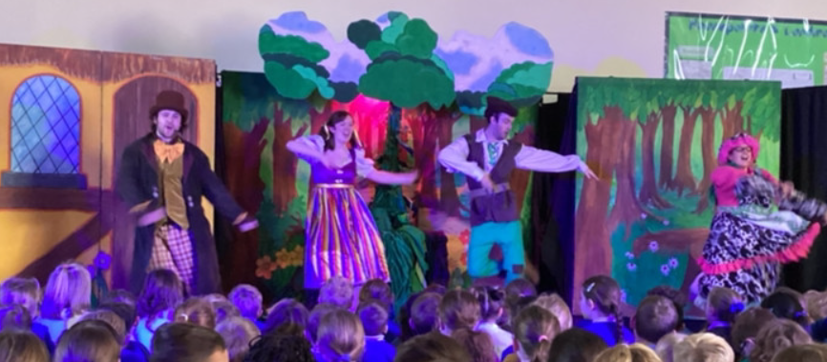
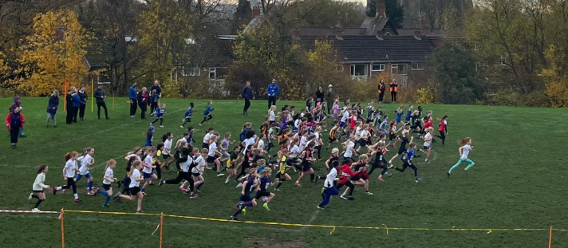
What’s been happening?
Cross Country
Children across Key Stage 2 have been taking part in cross country events over the past 2 weeks. On Saturday at the first LSSA event of the year and on Thursday at the Otley races. The children showed fantastic determination to complete these courses and really shone. We have several children making it through to future rounds as individuals and groups!
Thank you to parents for transporting and to our governor, Rhys Brown, for supporting with logistics. Children can sign up for cross country events until November 29th. If your child is interested in taking part in future events, please contact the school office.

Athletics competition
A group of Year 4 children took part in a sports hall athletics event today. They were superb and took part in all activities with enthusiasm. The children taking part were supported by a group of Year 6 children who helped to manage the event. Great job team!
Panto!
It is that time of year again... ‘Oh no it isn’t,’ ‘Oh yes, it is!’
We all thoroughly enjoyed our seasonal pantomime. This year, the story was Jack and the Beanstalk. The children were mesmerised by the acting and singing and, of course, thoroughly enjoyed the interaction - especially when Mr Kelsey and Mrs Hampson showed off their dancing skills! Thank you very much to the PTA for organising this event for us all.

