WEST END NEWS 21.11.25

Excellence, Confidence, Compassion, Happiness
Personal Responsibility, Social Responsibility, Environmental Responsibility
What’s been happening?
School council charity events!
School council were proud to feed back to school a big thank you from the local foodbank for all our harvest donations.
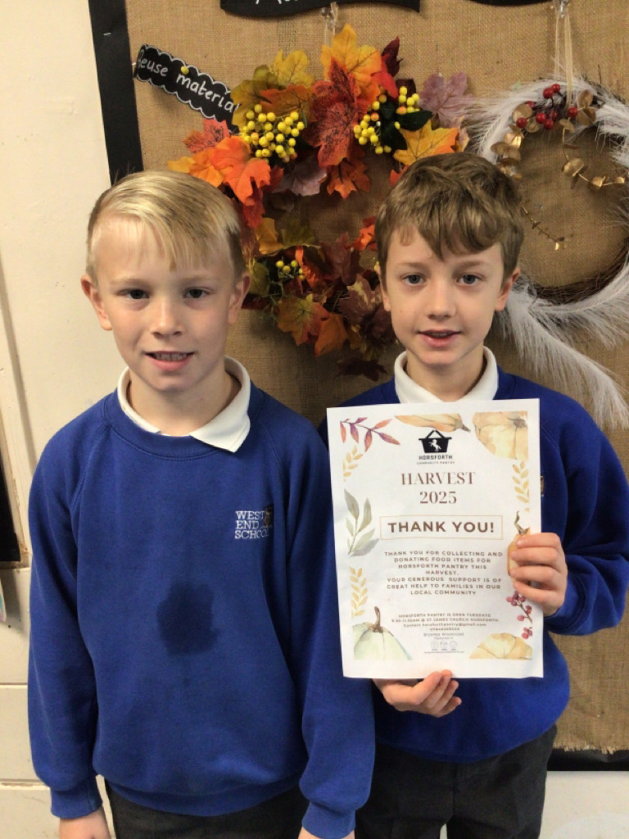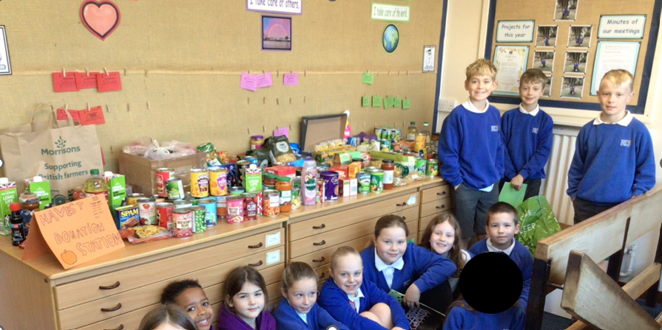
We had so many donations to help our local area, we needed lots boxes to pack it up all !
Children in Need update, we are also delighted to share with you we made an impressive £492.51 from our school bake sale. This is not including what some families donated directly to the website. Not only did we get to enjoy some delicious treats but we reflected on how BBC Children in Need fund vital support for children and young people struggling with challenges caused by mental health, poverty, social inequality and family-related issues.
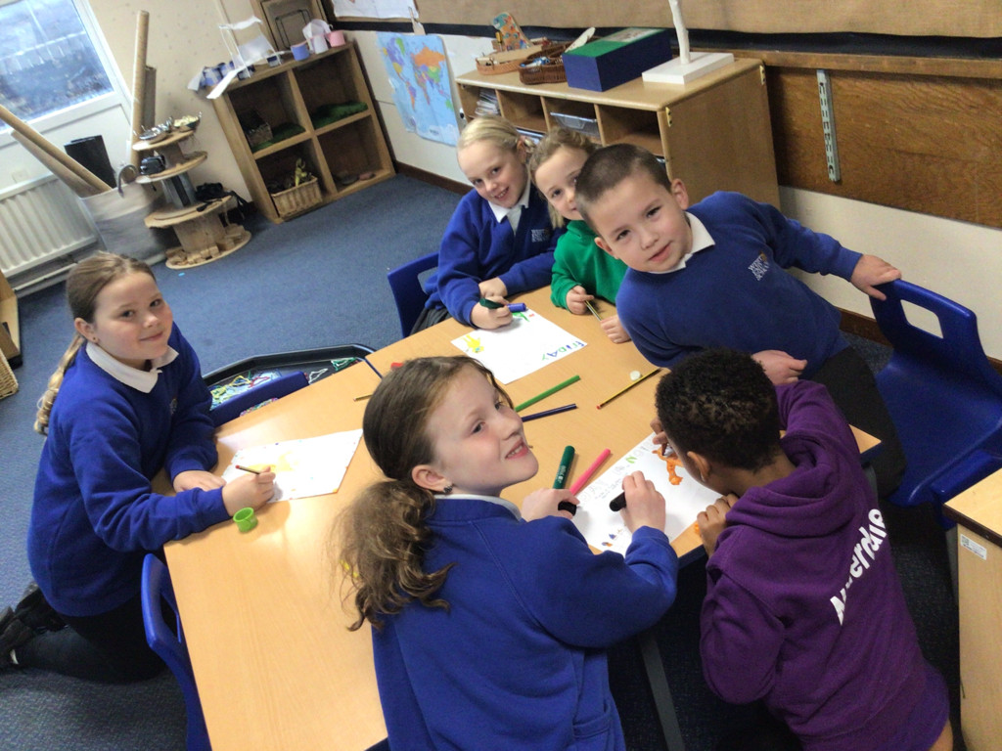
Other news
Thank you to Year 3 who delivered a spectacular assembly celebrating all their achievements so far this year. We loved seeing the cave paintings and the energetic cheer dance!
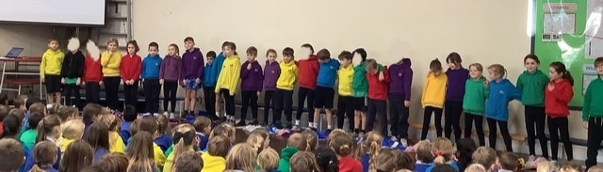
It was delightful to see so many families at parents evening this week to celebrate all the children’s hard work.

