WEST END NEWS 28.11.25

Excellence, Confidence, Compassion, Happiness
Personal Responsibility, Social Responsibility, Environmental Responsibility
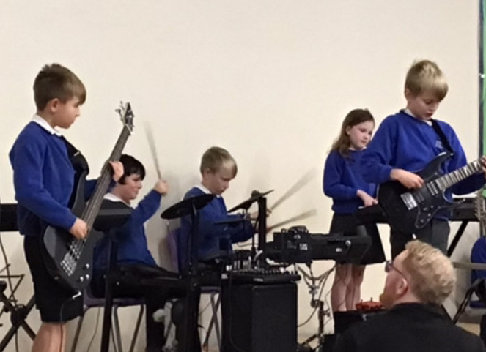
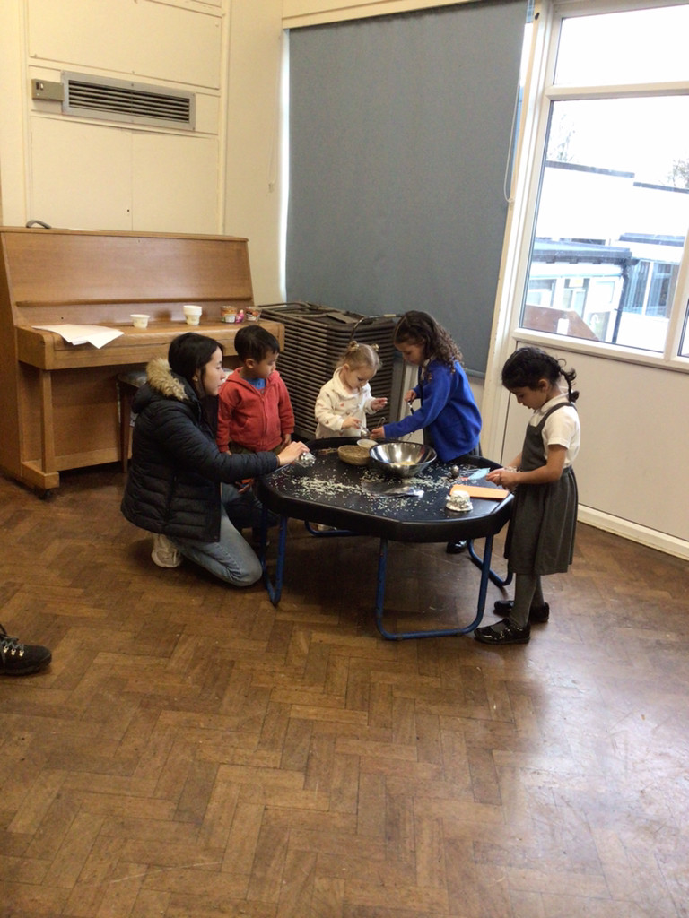

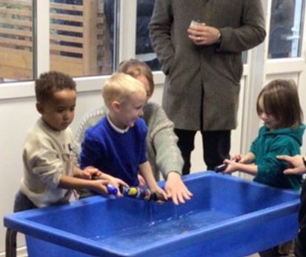
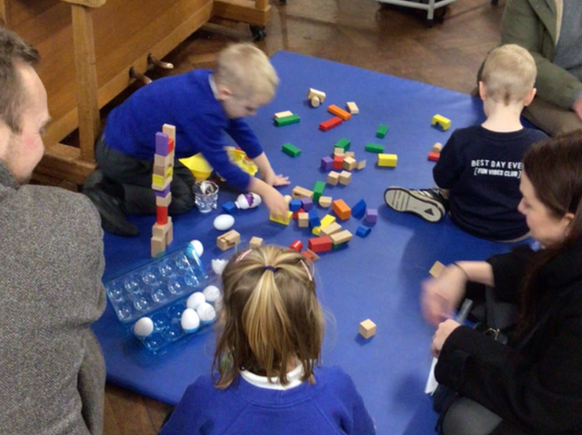
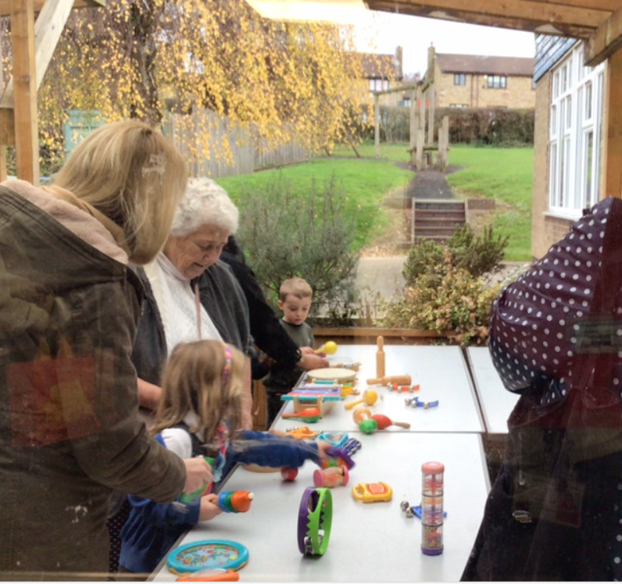
What’s been happening?
EYFS Nursery Rhyme Event
It was lovely to welcome parents and grandparents to our Early Years event on Wednesday. The children performed their favourite nursery rhymes, singing together and in rounds! Their performance of speaking, song and actions was fantastic. Following the performance, families were able to engage in learning stations linked to nursery rhymes. Everyone thoroughly enjoyed creating and making. Thank you to everyone who attended and to the Early Years staff team for organising this wonderful event.

Rock Steady Concert
Children across school performed in their Rock Steady band groups for their classmates and families. We all thoroughly enjoyed listening to their music with many of us clapping and singing along!

