Kestrel Topic Homework Autumn
This term we are learning about lots of different things in our exciting curriculum. This homework will let you investigate further something you are exploring in school. Please choose one of the suggestions below. How you present your work is entirely up to you. My ideas are just suggestions.
- Create a creature that could survive in the back seat of a car. Think about how it would eat, see out of the window, hide and protect itself. You could draw a poster, make a model or create a presentation.  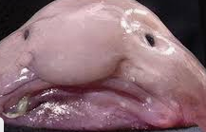 | - Create a newsflash announcing and describing a new creature that has been discovered in the deepest part of the ocean. Think about wat it would need to survive.   | - Create a mindfulness activity poster or activity. There are lots of fantastic websites online to help you with this.  
- Create a maths game which includes division and multiplication calculations.   | - Write about somewhere you went on holiday. This could be somewhere similar to the beach in the book ‘The Giant’s Necklace’.  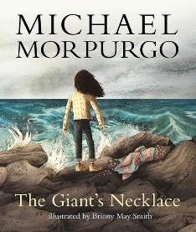 | - Make a family tree. Ask at home who you look like and add that in.  

