Kestrel Topic Homework Spring
This term we are learning about lots of different thins in our exciting curriculum. This homework will let you investigate further something you are exploring in school. Please choose one of the suggestions below. How you present your work is entirely up to you. My ideas are just suggestions.
- We are studying pilgimage. Research some examples of pilgrimages people go on. Where would you choose to go on a pilgrimage and why?  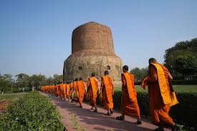 | - Create a shadow puppet show about a creature that haunts a spooky forest.   | - Create a mindfulness activity poster or activity. There are lots of fantastic websites online to help you with this.  
- Create a maths game that uses your knowledge of fractions.   | - Create a leaflet advertising Dracula’s castle as a really interesting place to visit. This can be funny or serious.  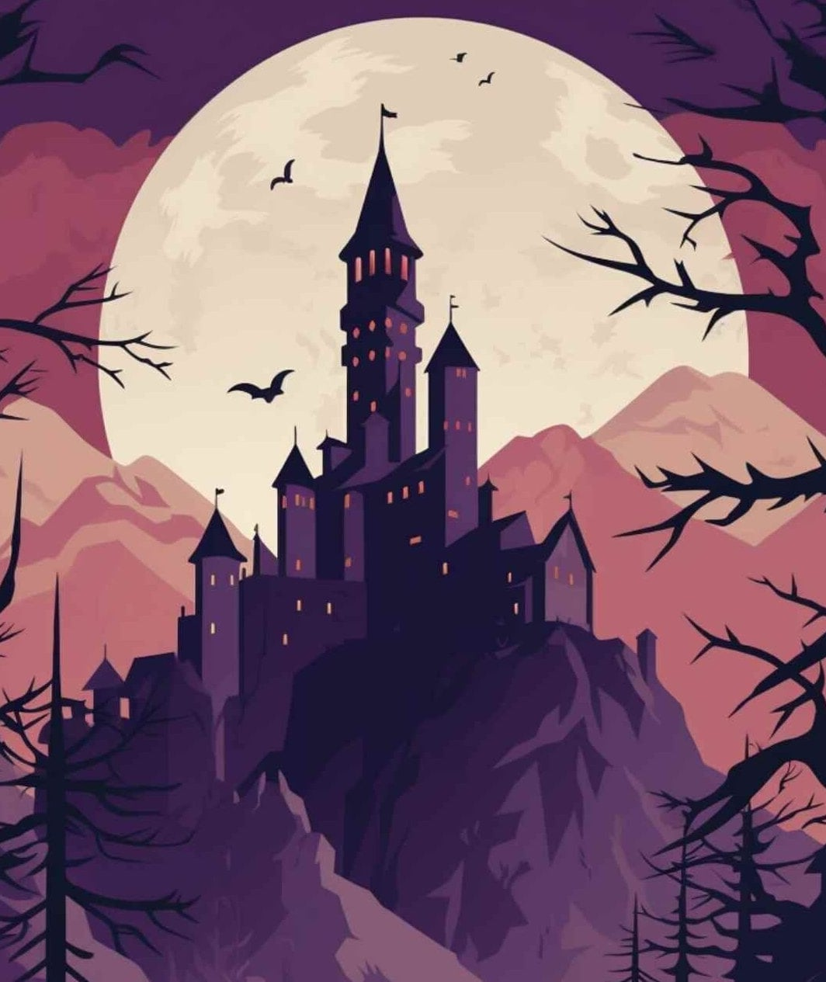 | - Create the front cover and the blurb for your favourite book.  

