WEST END NEWS 05.12.25
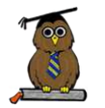
Excellence, Confidence, Compassion, Happiness
Personal Responsibility, Social Responsibility, Environmental Responsibility
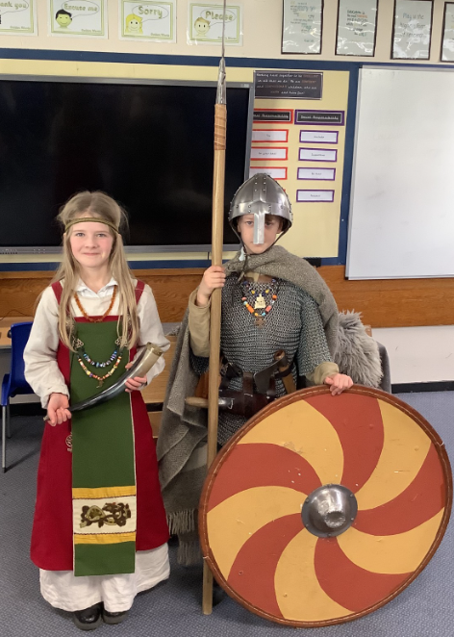
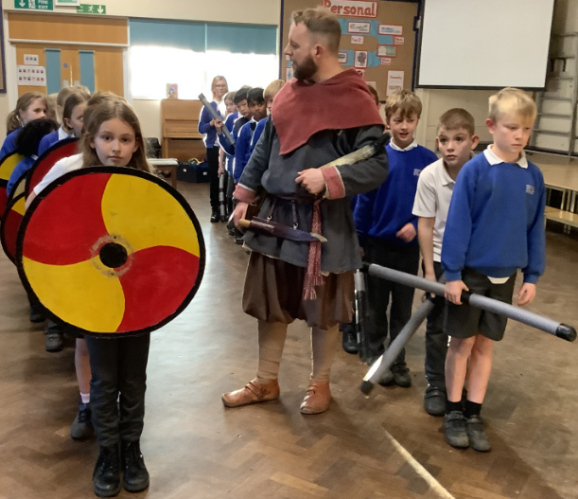

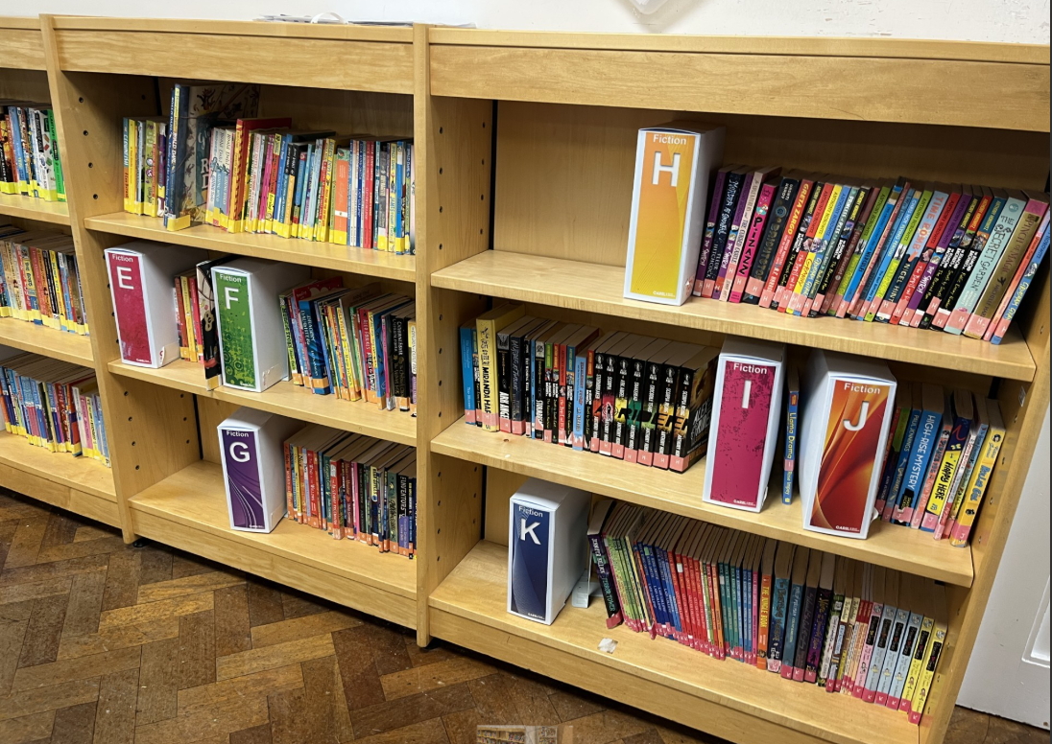
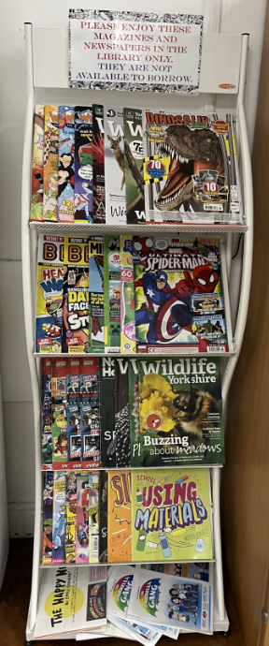
What’s been happening?
Year 5 Viking Visitor
Kite class had a truly wonderful and educational experience on Tuesday with our Viking Visitor, Olaf. From his arrival, he was in character the whole day and introduced the children to the world of the Vikings. He explained that his profession was a storyteller and the village would all come together at the end of the day to sit around the roaring fire where he told stories from over the generations. The morning included information about the history of the Vikings, where they came from, why they came to England and he showed the children many artefacts which they were able to hold and discuss. A couple of lucky children were dressed up. One being the lady of the village and I think Annabelle enjoyed the power especially sitting in my seat. Toby played a warrior going out to the battle and he was surprised how heavy the chainmail was. In the afternoon, an epic battle took place between the Vikings and Anglo Saxons with shields and spears (soft javelins). It was fantastic and all the children were involved, and the Anglo Saxons took the victory. We finished with a story by the fire. What a fantastic day, thank you Olaf!

School Library
Our library has had a makeover and restock. Thanks to our wonderful FoWE, we have over 200 new books to enjoy. The children are also excitedly taking part in a K-Pop Demon Hunters challenge and enjoying thinking about which new book they might like for Christmas. We hope you are enjoying the children's enthusiasm for reading at home and that your family story times bring you lots of festive joy over the coming weeks.

