WEST END NEWS 12.12.25
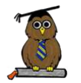
Excellence, Confidence, Compassion, Happiness
Personal Responsibility, Social Responsibility, Environmental Responsibility
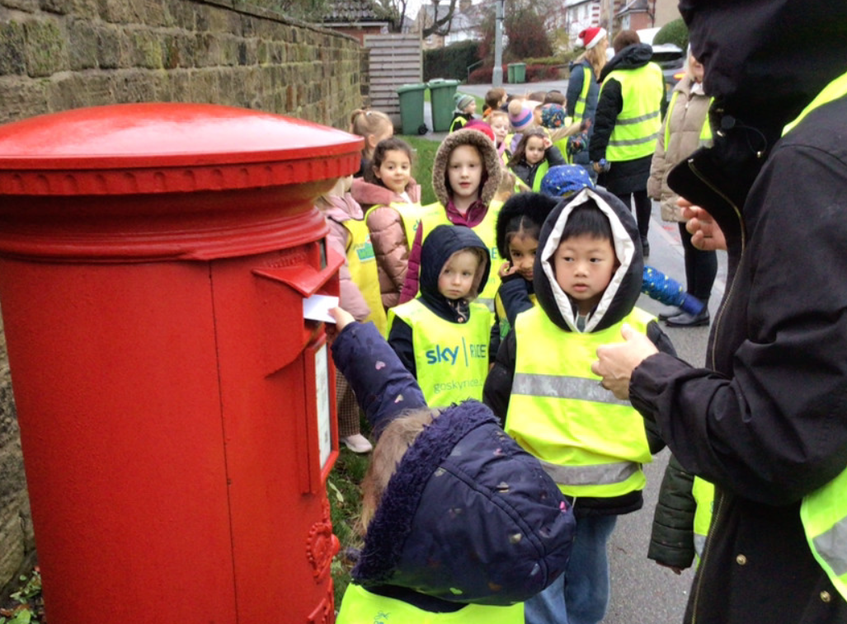
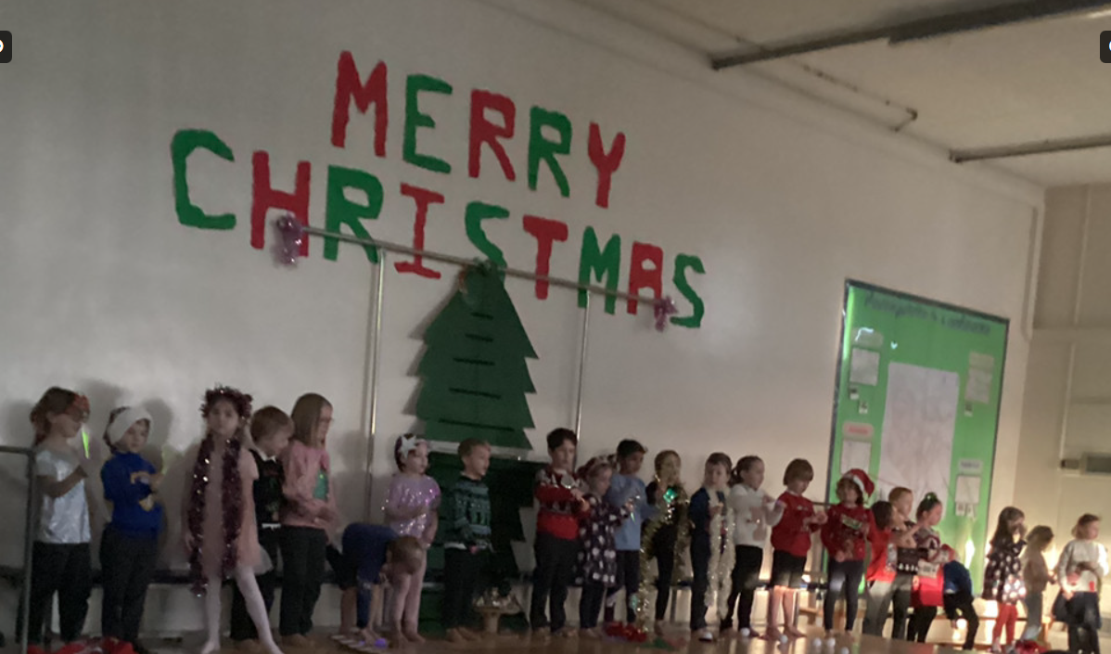
What’s been happening?
Christmas Concerts!
We have all thoroughly enjoyed welcoming you into school to share our Christmas performances. We hope you enjoyed them. The children have worked hard learning songs, dances, jokes and scripts (some of which they wrote themselves). Thank you for your support at home providing costumes and props and for taking the time to come and share in our celebrations!

Class trips:

Year 2 and Year 4 have been out this week to experience Christmas performances delivered on stage and ice! Everyone thoroughly enjoyed the experience.

Year 6 also visited a gurdwara to learn more about Sikhism and Robin Class have been out and about in our local area posting their Christmas letters.

