WEST END NEWS 19.12.25
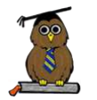
Excellence, Confidence, Compassion, Happiness
Personal Responsibility, Social Responsibility, Environmental Responsibility
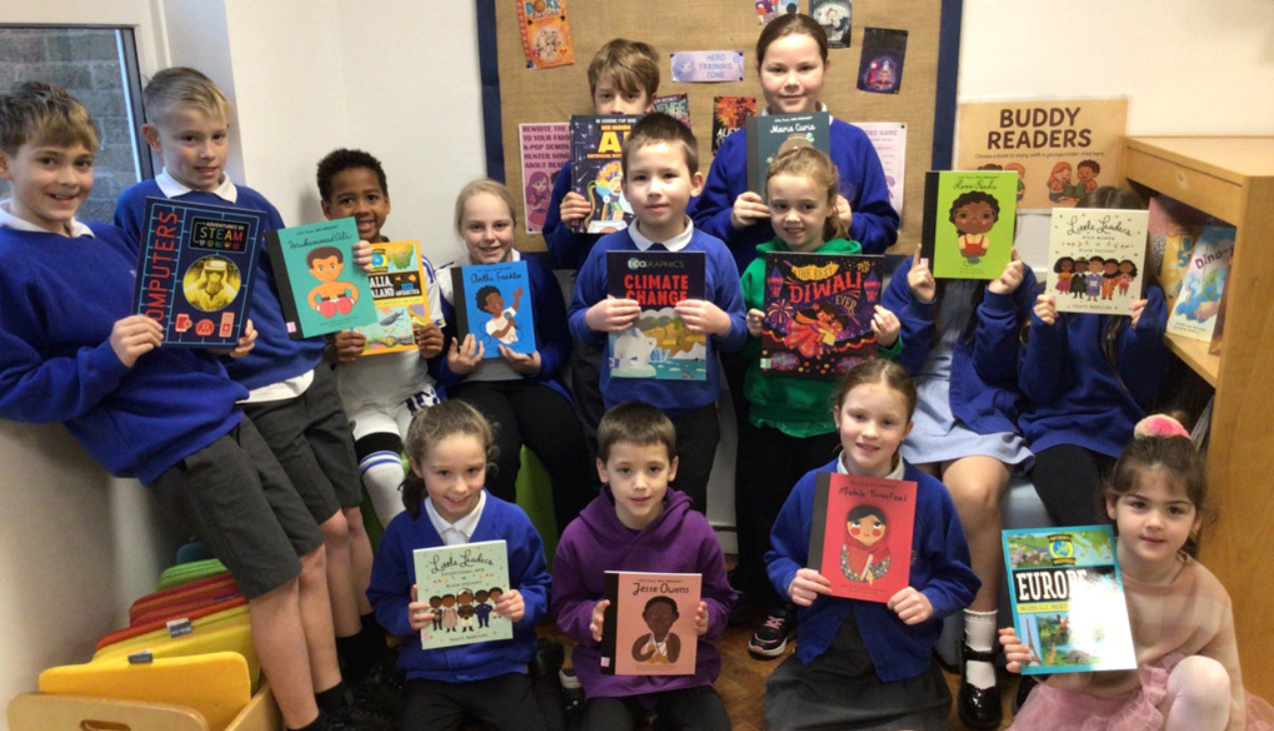
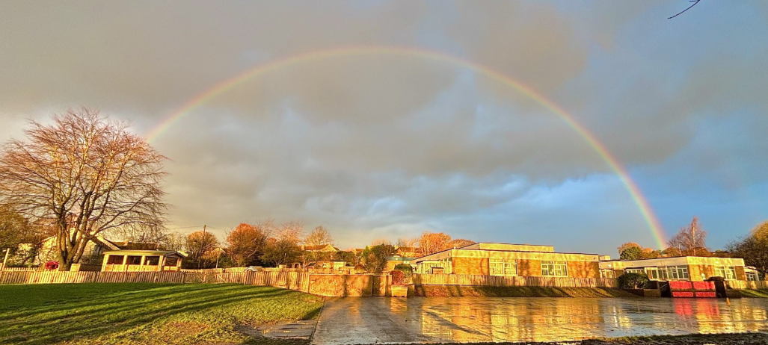
What’s been happening?
Recognition for West End
The Yorkshire Evening Post have released their top schools in Leeds list. This grading looks at both the academic outcomes for pupils as well as the Ofsted reports when inspecting the school.

We are thrilled to announce that West End has been ranked the 7th highest primary school in the Leeds area and the top primary school in Horsforth. This achievement is due to the hard work of our dedicated staff team, our motivated children, engaged parents and supportive governors. We should all be incredibly proud!
To read more, please follow the link:
https://www.yorkshireeveningpost.co.uk/education/the-27-best-primary-schools-in-leeds-5438572?page=2&fbclid=IwRlRTSAOpI2JleHRuA2FlbQIxMQBzcnRjBmFwcF9pZAo2NjI4NTY4Mzc5AAEePtzqQxAdyLJP4ska82i27Pjdfdp4JpE6YVaVS7uL9hmuDQ-PRnZEmdeDdoE_aem_J10OKMoR_09-2G4pBpaUVQ

Thank you to Mrs Munson for this wonderful picture of our school

School council update:

School council were delighted to receive lots of new books with the money raised from the school book fair. We raised an impressive £300 which was used to buy an exciting selection of new non-fiction book for the school library. School council were excited to feedback to their classmates and be the first to sort these lovely new books. Thank you so much for your continued support the library is looking fantastic.

