WEST END NEWS 09.01.26

Excellence, Confidence, Compassion, Happiness
Personal Responsibility, Social Responsibility, Environmental Responsibility
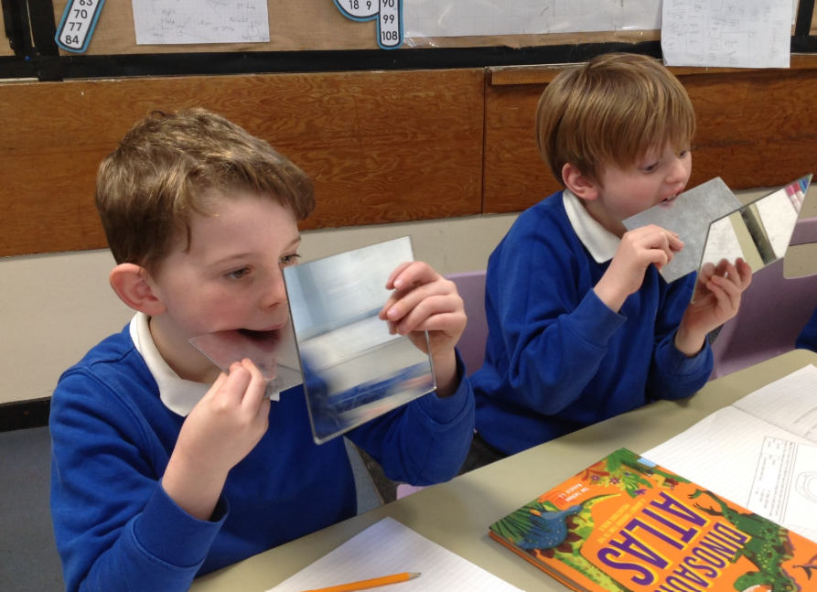

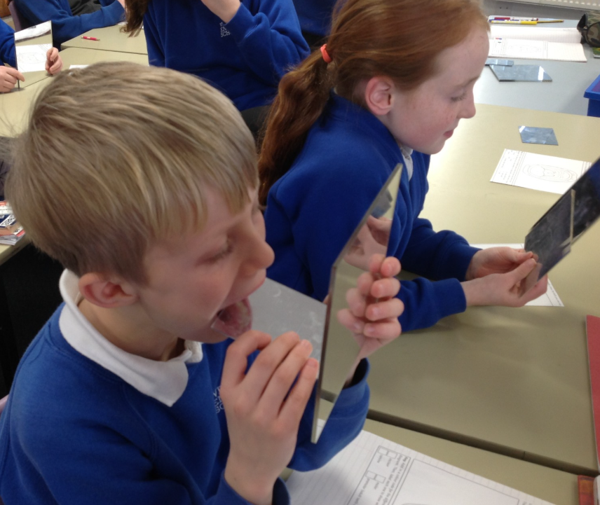
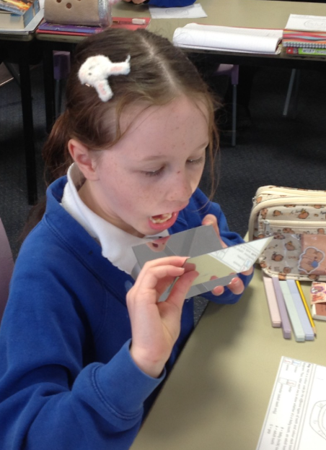
What’s been happening?
Happy New Year!
To start the new year, we have been discussing small changes we can make which will have a big impact for 2026 as part of our new year’s resolution focus. Pupils have set targets such as learning new languages and new instruments; dedicating more time to their hobbies rather than screens and increasing the time they spend on daily routines such as making their beds and brushing their teeth.

Year 4 have begun learning about the importance of our digestive system. This week, they observed their own teeth and recorded their own individual results using a key to indicate which teeth types they had and whether they were baby or adult teeth.

Next week, we have a dentist coming to talk to the whole school about the importance of good dental hygiene. We love it when members of our wider school community visit us in school to support our curriculum. If you are interested in offering an assembly and/or workshop to inspire our children, please get in touch with the school office.

Year 4 investigated how clean their teeth are as part of their science work. Next week, the whole school will learn more as we have a dentist visiting school to deliver an assembly and talk to some children in their classes!

