WEST END NEWS 16.01.26
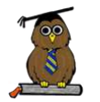
Excellence, Confidence, Compassion, Happiness
Personal Responsibility, Social Responsibility, Environmental Responsibility
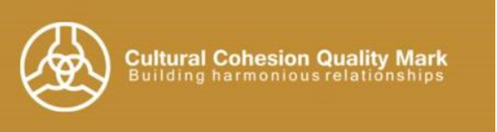
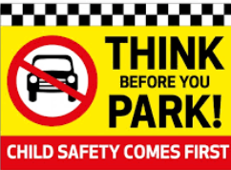
What’s been happening?
When wording our school vision, the children were clear that they wanted the word ‘together’ to show that everyone in our school is included. This vision and the school values of personal, social and environmental responsibility form the core of our school. To further embed our school vision and values, we are focusing on ways to develop our Equality, Diversity and Inclusivity (EDI).

To do this, we are embarking on the Leeds Cultural Cohesion Quality Mark (CCQM). Our first step on this journey is to make a pledge which the school will uphold.

The school staff and governors have worded our pledge:
We are committed to supporting our school community in being inclusive and respectful of everyone. We will immerse ourselves in diversity as widely as we can, embarking on a lifelong journey of learning about ourselves and others.

We would like the full school community to join us with this pledge and join us on our journey towards the Cultural Cohesion Quality Mark in the coming years.

Parking around school

In the poor light and dreary weather conditions it is even more important that parents and carers park responsibly enabling children to cross the roads and walk on pathways safely both to and from school. Please be aware that double parking on the roadway, parking on zigzag markings outside school, parking on single yellow lines within the restricted hours and parking on double yellow lines are all against the law. This law is in place to protect pedestrians and motorists. Please help to keep your children safe.

