WEST END NEWS 23.01.26
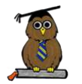
Excellence, Confidence, Compassion, Happiness
Personal Responsibility, Social Responsibility, Environmental Responsibility
https://www.youtube.com/watch?v=-lL07JOGU5o
https://www.nspcc.org.uk/advice-for-families/pants-underwear-rule/
https://www.youtube.com/watch?v=gfY_xrSQNEk

https://www.nspcc.org.uk/advice-for-families/

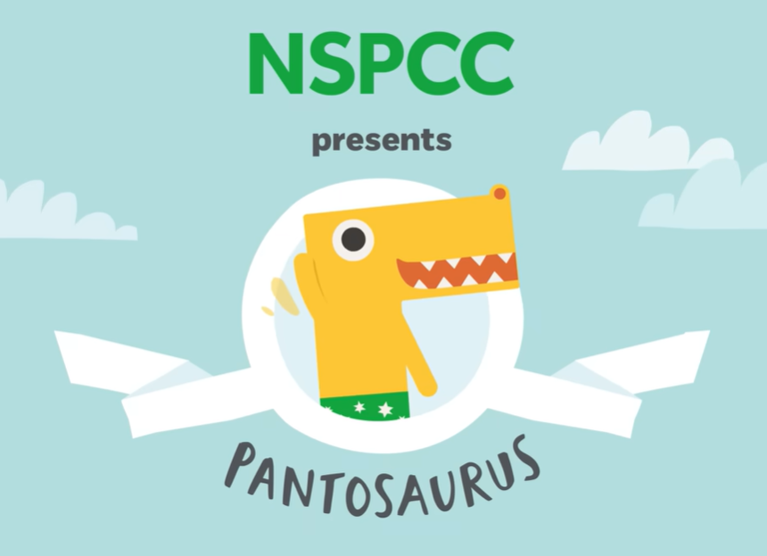
What’s been happening?
Over the coming weeks we will be looking at ways to keep ourselves safe and happy. This week we have been focusing on our school value of personal responsibility and the importance of keeping ourselves safe. In assemblies and in classrooms we used the NSPCC resources to support our learning.

Children have discussed ways to look after themselves and their friends. Speaking out if anything worries them and talking to trusted adults both in school at home.

If you want to talk with your child at home about ways to look after themselves, the links below may be of use:

Uniform reminder

A polite reminder to please ensure that children have the correct school and PE uniform. See the link below for further details.
https://www.westendprimaryschool.org.uk/page/?title=Uniform&pid=65

In the poor weather, it is important that the children have warm layers (coats, hats, gloves etc) and suitable footwear to keep them as warm and dry as possible. Children are welcome to come to school in waterproof boots / wellies to enjoy playing outside and have their school shoes / PE trainers in a bag to change into when they come back into school. Spare socks / tights can be helpful in the wetter weather too!

