WEST END NEWS 30.01.26
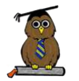
Excellence, Confidence, Compassion, Happiness
Personal Responsibility, Social Responsibility, Environmental Responsibility
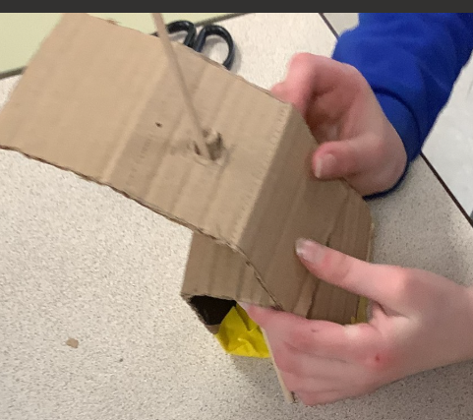
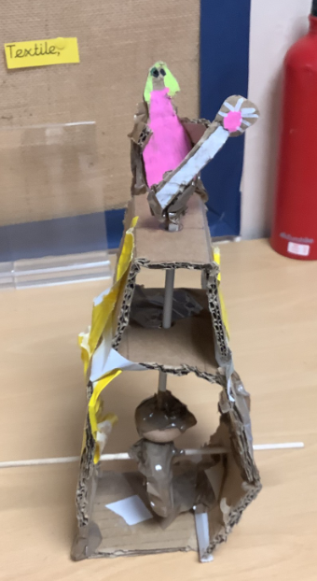
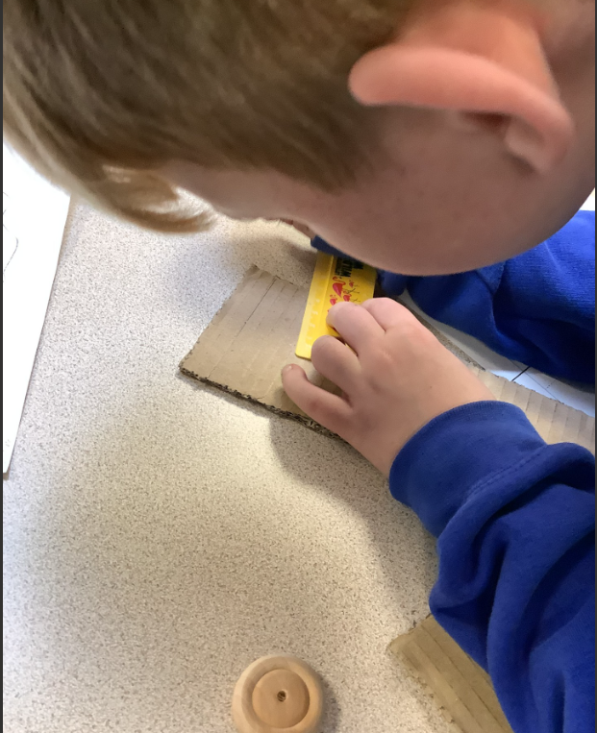
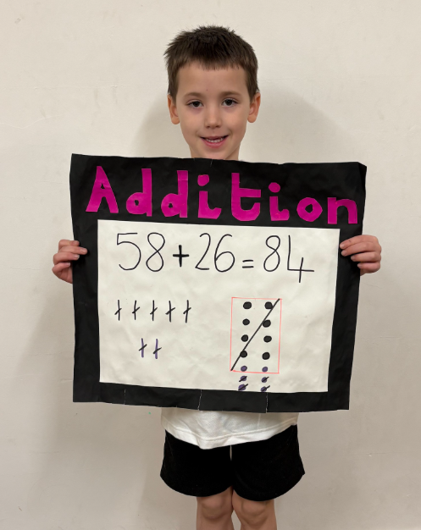
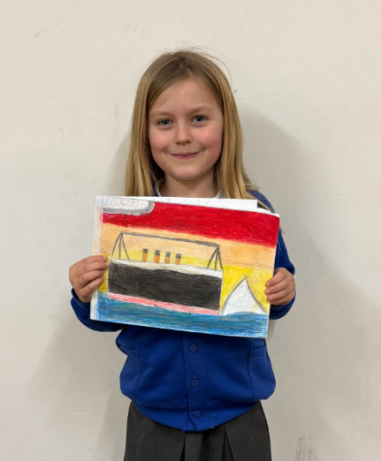
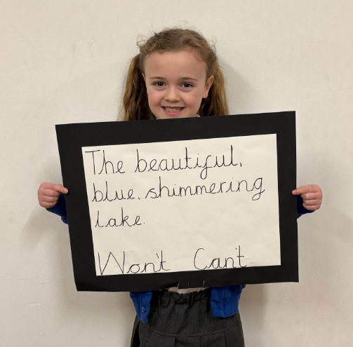
What’s been happening?
Year 2 Class Assembly

We all thoroughly enjoyed the Year 2 assembly this morning. The children shared their learning with us. Showing work, explaining facts and singing songs. It was wonderful to hear how much they have learned and see them present it so professionally. The singing was superb! Well done Year 2!

Year 5 Cam Mechanisms

Year 5 have been investigating different moving toys and their cam mechanisms in DT. They have explored and investigated different types of cam mechanisms and thought about the shapes they produced. To see the different shaped cams allowed them to see how they affect the linear movement of the follower. They then had to look at how to strengthen the moving toy structures. This allowed the children to design a moving toy with their choice of cam. Once designed, they followed this design to create a moving toy with a cam mechanism. They finished the project by evaluating both their process and their finished product.

