WEST END NEWS 06.02.26

Excellence, Confidence, Compassion, Happiness
Personal Responsibility, Social Responsibility, Environmental Responsibility
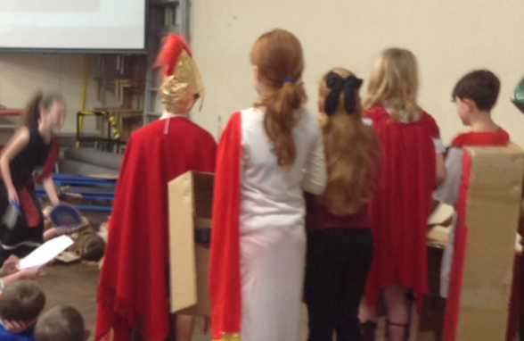
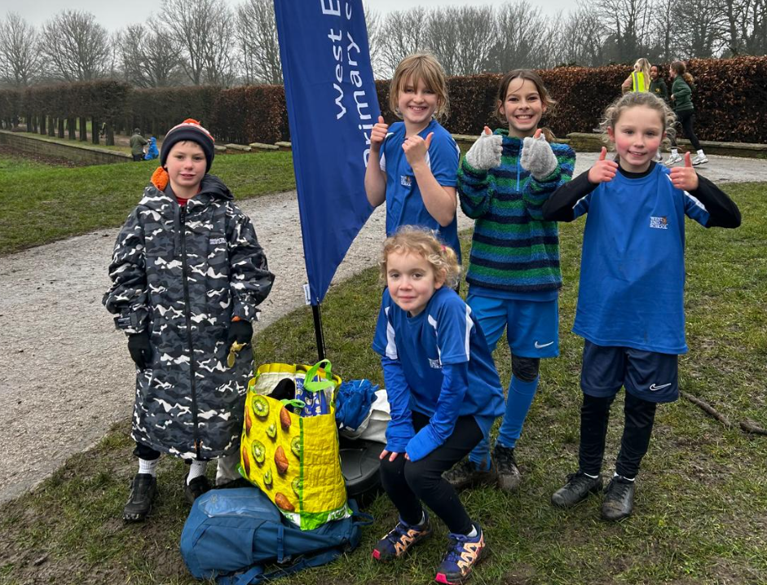
What’s been happening?
Year 4L Class Assembly
Year 4L's assembly was inspired by their visit to Leeds Royal Armouries where they took part in two workshops that provided them with first-hand experience of being a Roman soldier and an Iceni warrior. This morning, they imparted their Roman invasion knowledge and consolidated their Roman knowledge. Taking us back in time to 54BC when the Romans invaded Britannia. Boudicca led her Iceni tribe to the battle where they were defeated by Caesar's Roman army. The Roman invasion of Britain is arguably the most significant event ever to happen to the British Isles. The Romans affected our language, our culture, our geography, our architecture and even the way we think.
Around 2,000 years ago, Britain was ruled by tribes of people that called themselves the Celts. For around 100 years, the Roman army had been building an empire across Europe. The Romans wanted Britain's precious metals gold, tin and iron – and its cattle. A number of Roman emperors wanted the glory of conquering Britain and adding it to the empire.

Cross County – Leeds Finals
Congratulations to all the runners who took part in the Leeds Cross Country Final at Temple Newsam. We were exceptionally proud of the children and the way in which they represented our school - they were great athletes who demonstrated wonderful sportsmanship. The children ran incredibly well coming 1st, 12th, 14th, 25th and 32nd. Amazing results! We know that we will have several children representing West End at the West Yorkshire Cross Country final - we can’t wait to see what they achieve there!

Pencil case top up reminder – all to go home at the end of half term

Emma Leeds Half Marathon

PTA sell piano

Training Days 2026 - 2027
Tuesday 1st Sept 2026
Wednesday 2nd Sept 2026
Monday 30th Nov 2026
Thursday 25th March 2027
Friday 28th May 2027
These dates are posted on our website.

